1. **At first, update package repositories. Then check the available commands for apt using command help. What commands are used to perform the following tasks with apt:  
     
   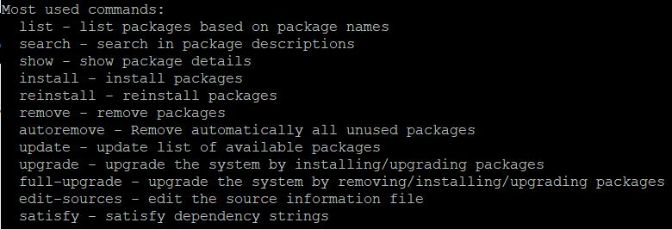**
   * **Upgrading installed packages in the system  
     **
   * **Removing unused packages from the system  
     **
2. **Check the information for the package called figlet and answer the following questions:  
    apt info figlet**
   * **What is the size of the package?  
     **
   * **What is the newest version available for the package?  
     **
   * **Check the package description → What does the program do?  
     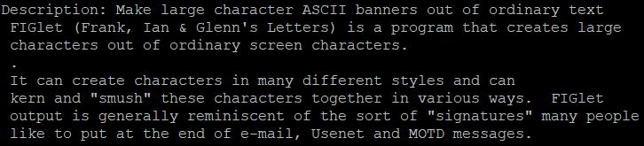**
3. **Install the figlet package and verify it works.  
     
    figlet hello students**
4. **Remove figlet from the system with all configuration files. Check that program cannot be run after the removal.  
     
   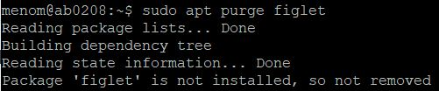 figlet hello students (verify)**
5. **In this task you must install Python3 by compiling it from the source code. Download the package from the url**[**http://student.labranet.jamk.fi/~hantt/os/Python-3.7.4.tgz**](http://student.labranet.jamk.fi/~hantt/os/Python-3.7.4.tgz)**.  
   **
   * **Before the compilation process, install the following packages with apt:**sudo apt install build-essential
     + **libffi-dev**
     + **zlib1g-dev**
   * **If you cannot start your newly installed Python3 fix the symbolic link to point for the *python3.7* executable.  
      tar -xf Python-3.7.4.tgz** then cd Python-3.7.4 **then sudo ./configure then sudo make install  
     **
   * **Verify the operation of Python3 by starting the shell with command python3. You should now see the version 3.7.4 at the start of your Python shell.**cd  
     python3 **which python3  
     which python3.8  
     sudo rm /usr/local/bin/python3  
     sudo ln -s /usr/bin/python3.8 /usr/local/bin/python3  
     python3  
       
     **

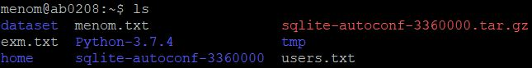

**(Watch recording for the last one again)**